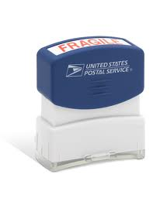
Vincent Morse
Mrs. Rutan
Creative Writing
30 October 2013

Foreword
THUD! Another stamp—like the pre-inked slam of a bank teller declining a loan. These are starting to get old. Time and time again, outside influences want to leave their mark on you. Everybody wants you to learn something; to make an association or connection.
The context of my story is not to give you “insight” or change your life. I’m simply recalling stamps of memories tattooed into my brain and putting my new found creative side to use. Enjoy.

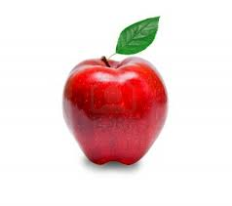
The ABCs of Personal Interpretations
A if for Apple
Apples are such a fruit. At this point you’re probably thinking well no shit, but think about it. They are the fruits of all fruits; the king of fruits; the remedy of doctor frequency illness. To my own demise, I cannot take part in the apple loving. You see, my face and a soccer ball became well acquainted and I now have 3 chipped teeth. In place of the missing bones are carefully sculpted molds. I’m afraid that if I sink my teeth into fruit royalty, I may never seem them again. Poor me.

B is for Boy
Yes, believe it or not, I am in fact a boy. I may not have the most aggressive behavior or the feeling to prove my gender, but my loins remain the same.

C is for Cat
I miss my cat. His name was Herman. Yes, like the name of an elderly man who creeps everyone out—his personality did not vary. It seems that my sister went through that little girl stage in which she finds the most irrelevant, off-the-wall names to call her pets or teddy bears. She’s now a writer and has failed to leave that stage.

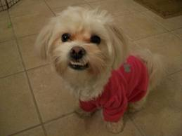
D is for Dog
You know that point where a dog can be so ugly that it’s cute? I don’t think my Ava is there, she teeter-totters on the line and I don’t think an under bite—in any circumstances—could be considered adorable. I suppose it’s not a full under bite. Only a lonely few crooked teeth to match a crooked smile—if dogs can do so (I believe they can). I feel bad for the thing. She’s a Maltese-Bishon mix; even the names are kind to the ear. What she lacks in looks, she makes up for in stupidity. She is to the point where she’s so dumb, it may possibly be cute.

E is for Elephant
Elephants have immaculate memory; I however, cannot even remember how I intended to end this sentence. I always envy those who can recall an event from years ago. I could never even answer the inevitable dinner question demanded by my father, “What’d you do in school today?” So yes, I am jealous of fat, grey, wrinkly, animals.

F is for Friends
…who do things together (excuse my inner child reciting SpongeBob). This is probably the most important letter—at least to me. I think about my friends a lot and my biggest fear is losing them. I would go insane, or reach new levels of insanity, without them. I’m not a spiritual person but God bless.

G is for Goat
Many people see goats as funny livestock, but this is my story and I’m telling you, they’re demonic. Dirty birdies. I work at Binder Park Zoo and a well-known commodity is the petting zoo filled with Billies. They’re vicious creatures I tell you. They’re predatorial when you grasp that 25 cent feed. Beware.

H is for Hippo
To be honest I have no real connection with hippos, oh wait! There’s these chocolate hippos my dad brings home from Germany that are so good. So good, in fact, that I wish they were life sized. Delicious little things.

I is for Igloo
I’ve never made a successful igloo, only white disappointment that usual cave in on top of me. Just like my architectural dreams. I do love the snow though; I find it calming. Though I cannot find joy in an igloo, season festivities and whiteout storms keep me merry.
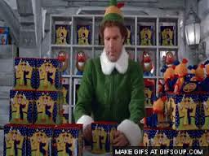
J is for Jack-in-the-Box
This brings great vivid memories. Not of my own experience with a Jack-in-the-Box, but of Will Ferrell. His scene in Elf testing toys is so remarkably funny that I can’t help but to laugh out loud. It’s an irresistible humor deserving of a chuckle.

K is for Kangaroo
I have to say, I’m a tad envious of kangaroos because they have something that I don’t. Their pouch. It’s like a backpack, but more of a front pack. A marsupial pouch would be much more applauded than a fanny pack.

L is for Lion
I had a lacrosse coach that I mentally named Lion. His hair color matched the ideal orange and surrounded his face; this was obviously his mane. When referring to his spirit, he may have starred in Wizard of Oz if you catch my drift.

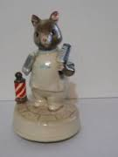
M is for Mouse
I once read that there is such a thing as a Barber Mouse. Yes, the kind of barber that cleans you up and trims your hair. I hear they’re having a $7.00 special sale next Thursday. Scientists claim that if mice are kept together in a lab, one will assume the barber role. This phenomenon has never been witnessed, but when the lights go off, the mice clean their clippers and get to work. “What’ll it be for ya today?” “Ohh just a little of the sides please, tryin’ to keep it fresh.”

N is for Nest
When I hear nest, I think of home; the place where you’re comfortable the most. I don’t necessarily think that it’s a specific place, more of who’s in your heart. I remember the story of a friend’s friend. She said that when she left home for college, it was not her house she’d miss, but her brother. The thing she’d miss the most was her little brother; that was who was in her heart—her comfort. I’ll never forget that story.

O is for Octopus
To be blunt, those things scare the hell out of me. The fact that they have 8 legs makes me feel suffocated, like they’ll latch onto my face and never let go. Now you know one of my many fears.

P is for Penguin
One of my favorite places to go is aquariums. Don’t ask me why because I don’t know, they just fascinate me. The coolest exhibit? The penguins of course. I like to see the different species interact, they’re similar to people, so instead of people watching, you’re penguin watching.

Q is for Quilt
My best friend’s family tradition entitles him to a quilt. When a Wilkie graduates, the mother ask everyone in the family to draw a memory and send it to her. She then stitches each and every image into the quilt of memories. I’m still working on the adoption—just for the quilt of course.

R is for Rocket
I still to this day contemplate if I would go to space if given the opportunity. Probably not. Could you imagine? You’d be weightless, feeling invincible Maybe the rocket I shot off in middle school made it—I never did find it. One can only hope.

S is for Snake
I have a very clear memory for this one. I was 7 years old and it was 4 o’clock in the morning when my father woke me. In my baby blue race car attire, I stumbled outside to the attempt of a garden in front of my house. In the red wood chips slithered a snake. Ribbbit. What? A hiss; a rattle; a slurp; anything but a ribbit was expected. I was then rushed to bed in a daze. Today, I now know that the lump in the snake was not an injury or a pregnant belly. I regret to inform you that 178 Singletree Lane has one less frog.

T is for Toy
Ever heard the phrase “men don’t outgrow their toys, they buy bigger ones?” It’s one of my favorites. I want to be that person who traps their inner child for old age. I’ll always be young at heart.

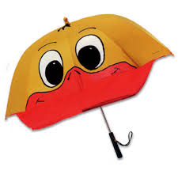
U is for Umbrella
My mother had a yellow ducky umbrella—bill and all. One day going to a soccer game it began to sprinkle, so I made the kind gesture of offering my dad the iconic duck. To my astonishment he refused, but why? “What would people think if they saw your dad with something like that?” dignified his refusal. They’d think “Man that guy looks dry and fly at the same time” ran through my head. We have different styles I guess.

V is for Violin
Have you ever heard an electric violin? It’s different to say the least. Every year near Christmas, my family and I go to see Trans-Siberian Orchestra. They’re a band that rocks out to Christmas music. What could better this show? Oh yeah, a laser show. So we see an Asian musician head banging behind a violin echoing Christmas music, all while lasers attack the audience.
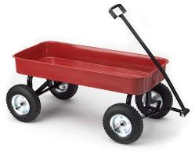
W is for Wagon
You might be a redneck if you and your sister’s “fun” growing up was taking turns in wagon rides around the yard. It usually ended with a disastrous crash into the corn field.

X is for Xylophone
Not much to say here because I never had one—at least to my knowledge. They sound cool though.

Y is for Yarn
My girlfriend’s mother is into all the crafty stuff so she has yard strewn about their house. One of the best gifts I received was a knitted pair of mittens and slippers from her. Somehow the yard ball that rest upon my slippered foot doesn’t appeal to Sadie; I wear them in spite of her.

Z is for Zebra
I have some trusted sources and from what I’ve heard, zebras are mean and nasty things. It’s kind of disappointing after watching Stripes. I half expected them to start talking. I wonder if what they have to say is mean too. Next time you see one lean in close—but not too close—and whisper “I know your secret.”

Backword

After reading this you’ll think that it has no substance, no meaning to my words. And you may be right, but will you remember? That is the million dollar question; did I leave my stamp on you—the reader. Nothing you write has to be gold. All you need to do is include a piece of you to be passionate about. In order to inspire, you must first be unique to yourself. The rest will come naturally. I wish you luck with your further writings and thoughts. Live long and prosper.

